APPLICATION FORM for Carbon Neutral certification
Please complete electronically and return by e-mail
By returning this application form you agree to our data protection declaration.
See https://controlunion-germany.com/en/privacy-policy

NAME OF COMPANY APPLYING AND LEGAL STATUS  (please use full name of company with e.g. Ltd., Inc, etc.) | ADDRESS OF COMPANY  (Street, post code, town, province, country, P.O. Box)
COMPANY’S LEGAL REPRESENTATIVE  (name of person and function) | COMPANY’S CONTACT PERSON  (complete if different from Legal Representative)
VAT NUMBER OF THE COMPANY | E-mail and/or Website

I am completing this application form because I wish to receive a non-obligatory offer for Carbon Neutral certification of my organization/product/event/project.
☐ Applying for the first time
☐ Indicate changes if you are already our client.
Applying for additional services:
☐ Pre-assessment

- Your desired scope
☐ Carbon Neutral certification – organization
☐ Carbon Neutral certification – product
☐ Carbon Neutral certification – event
☐ Carbon Neutral certification – project
☐ Carbon Neutral certification – other: (please specify)
according to PAS2060:2014 – Specification for the demonstration of carbon neutrality

- Engagement
If possible, please attach the prepared Qualifying Explanatory Statement for Carbon Neutrality to this application.
Verification of Qualifying Explanatory Statement (QES)
according to ISO 14064-3:2006 – Specification with guidance for the verification and validation
of greenhouse gas statements

- Description of business activity
Please provide a short description of your business activities, company sector:

- Description of certification scope
Please provide a further description of the subject (organization/product/etc.) to be certified.

- Description of application period
Please specify the (planned) baseline date and length of the application period.
The length of the application period depends on the preference of the applicant, but every application period should be of equal length. One calendar year is the most common option. Further information on the carbon neutrality process is included in Annex 1.

- Aim of certification
Please specify the application of the resulting Carbon Neutral certification. (choose one or more of the options below, or specify in the last row)
☐ Making a Carbon Neutral claim for my organization/product/etc.
☐ Meeting conditions of stakeholders or of a (potential) client
☐ Fulfilling a (legal) compliance obligation
☐ Other: (please specify)

- GHG inventory, baseline and baseline scenario
Please include quantitative reference(s) of the subject’s GHG emissions that (would) occur in the baseline scenario. (no measures to reduce or offset emissions taken)
☐ The following GHG sources must be considered:
GHG Source | Quantitative reference

☐ The following GHG sinks must be considered:
GHG Sink | Quantitative reference

☐ The following GHG reservoirs must be considered:
GHG Reservoir | Quantitative reference

☐ For all above SSRs, the following base year is considered:
☐ The project’s GHG emission (reduction) report or statement is attached to this application

- Material processes and flows
Please describe the subject’s material processes and flows that impact emissions.
Material processes:

Material flows:

- Quantification methodology
Please indicate the methodology used to quantify GHG emissions.
☐ Calculation, based on:
☐ GHG activity data multiplied by GHG emission or removal factors
☐ the use of models
☐ facility-specific correlations
☐ mass balance approach
☐ Measurement, mode:
☐ continous
☐ intermittent / periodic
☐ Combination of measurement and calculation

- Carbon footprint management

- Baseline period exceptions (only applicable for the first application period/baseline period). Please indicate which baseline period exceptions are made use of. (if any).
☐ Inclusion of historic reductions (emission reductions prior to the baseline date)
☐ Exclusion of carbon footprint management plan – exclusively using offsetting to account for all
GHG emissions associated with the defined subject

- Applicable legislative standards and other normative documents
Please list standards and other normative documents relevant to your certification scope, or attach list of those. (e.g. standards used for GHG quantification)

- Level of assurance
By default, verification according to ISO 14064-3 is conducted at a limited level of assurance. In case verification at a reasonable level of assurance is preferred, please indicate so below.
☐ It is preferred that verification is conducted at a limited level of assurance (default)
☐ It is preferred that verification is conducted at a reasonable level of assurance

Please list standards and other normative documents relevant to your certification scope, or attach list of those. (e.g. standards used for GHG quantification)

Undersigned declares to have completed this Application Form truthfully

NAME ORGANIZATION

LEGAL REPRESENTATIVE
(The person of the organization, accepted by the Chamber of Commerce registration as authorized.)

DATE & SIGNATURE

Note:
Please send us copies of documents to prove the legal status of your organization along with this application, e.g. Business registration certificate/ Chamber of Commerce registration certificate.
Based on the above information, Control Union Certifications will draw up a non-obligatory offer for a contract.

SEND TO:
Control Union Certifications Germany GmbH
Bornitzstraße 73-75
D-10365, Berlin
Germany
Tel.: +49 (0) 30 509 69 880
Email: berlin@controlunion.com

Annex 1: Carbon neutrality process
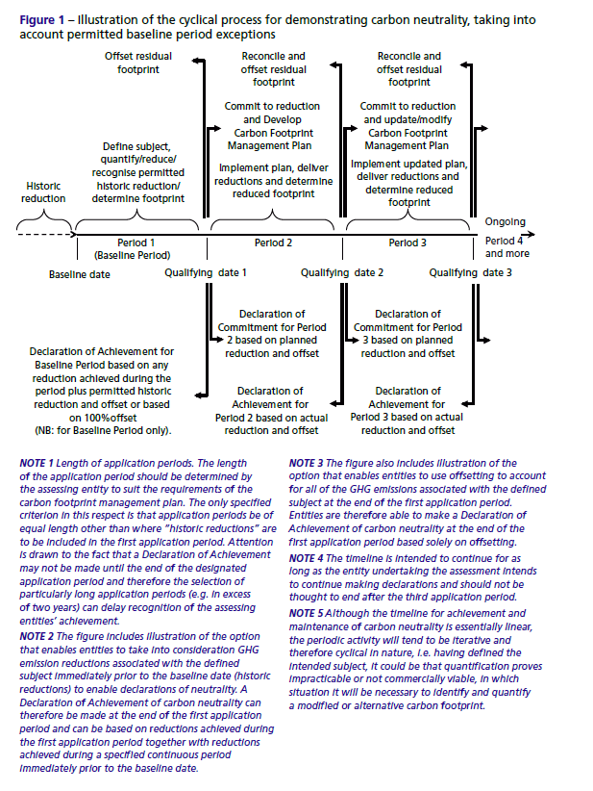
Source: PAS 2060:2014 – Specification for the demonstration of carbon neutrality

